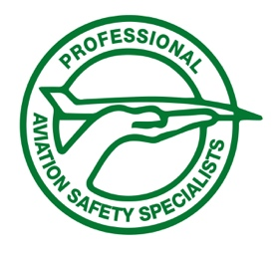
PROFESSIONAL AVIATION SAFETY SPECIALISTS
1200 G Street NW, Suite 750 • Washington, DC 20005
Telephone: (202) 293-7277 • Fax: (202) 293-7727

Founded 1977

Date

Sincerely,

